**Business | Bartleby**

**商业 | 巴托比专栏**

（英文部分选自经济学人202200827商业版块）

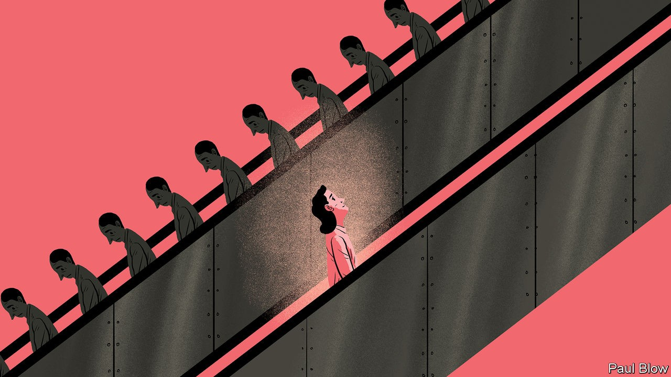

Is **travelling to work** always a waste of time?

**通勤**总是浪费时间吗？

In defence of **commuting**

**通勤**辩护录

Americans are “always in a hurry”, wrote Alexis de Tocqueville in “Democracy in America”, his opus published in 1835. **Until the covid-19 pandemic, nowhere was this more evident in recent decades than in packed trains at peak times as people commuted to work.**

美国人“总是行色匆匆”，亚历西斯·德·托克维尔（Alexis de Tocqueville）在其1835年发表的著作《论美国的民主》（Democracy in America）中写道。**近几十年来，这一点在人们上班高峰时段的拥挤火车中最为明显，直到新冠疫情爆发。**

Almost 75% of professionals in America say the journey is what they dread most about going back to the office. **Working remotely a few days a week is here to stay.** Rush-hour traffic, overcrowded trains and transport strikes (like those on London’s tube in the past week) all **argue for** working from home. Across America and Europe rising fares eat into people’s salaries. The outcry for lower carbon emissions adds additional weight to the argument for millions of employees not undertaking unnecessary journeys. In some emerging cities, getting to work involves honks and epic gridlock as well as accidents.

近75%的美国专业工作者表示，通勤是他们回归办公室的最大噩梦。**每周远程办公几天的工作模式会成为未来常态。**高峰时段繁忙拥堵的交通、拥挤不堪的火车和各种交通罢工（如上周伦敦地铁罢工）都是居家办工的理由。美国和欧洲通勤费越来越高，人们开销越来越大。降低碳排放的呼吁为数百万员工在家办公的主张增添了底气。在一些新兴城市，上班路上不可避免会伴随着汽车鸣笛、道路拥堵以及交通事故，场面一片混乱，乌烟瘴气。

注释：

地铁大罢工！巴士大罢工！英国伦敦公共交通几近瘫痪

https://finance.sina.com.cn/jjxw/2022-08-21/doc-imizirav9014447.shtml

**Every now and again, most people will nevertheless need to make the trip to the office and back.** Whether you are walking, cycling, on a Vespa, taking the bus, the tram or the subway, **（the range of options is wide, and rich in** texture **and colour）.** **Some people will insist that no commute is ever worth the trouble**. With the right attitude, though, it does not have **to feel like temporary brain damage**. This guest Bartleby, who takes the underground to The Economist’s London office three times a week, finds it both useful and oddly fulfilling.

**然而，大多数人偶尔还是避免不了要往返于办公室。**无论你是步行、骑自行车或是摩托车、坐公交、乘坐有轨电车或地铁，**都有丰富的通勤选择，各式各样，五花八门**。**有些人坚持认为，任何通勤都不值得**。但如果你摆正一下心态，也就不会觉得通勤如此**让人头痛了**。本人作为巴托比专栏储备编辑，每周有三天要乘地铁到《经济学人》伦敦办公室，就觉得通勤不但有好处，还会有一种奇妙的满足感。

注释：

伟士牌（意大利语：Vespa，意为黄蜂，也称韦士牌）是意大利摩托车制造商比亚乔旗下的一个子品牌，主要生产踏板式两轮轻便摩托车。自其1946年诞生以来，伟士牌公司生产的摩托车一直保留着最初型号的外观特征，并保持着小巧、紧凑的特点。电影《罗马假日》中男女主角骑着的便是伟士牌摩托车。

https://zh.wikipedia.org/wiki/%E4%BC%9F%E5%A3%AB%E7%89%8C

Just how useful and fulfilling will depend on what exactly your commute looks like. But unless you **hop into** your car on your driveway and **hop out** at your company car park, it will involve at least some physical activity. If you are cycling, or just picking up your walking pace to catch that bus or train, you combine being outdoors with an element of struggle—a healthy amount of which can be invigorating, not draining. And if you don’t catch it, don’t worry. Your hours have almost certainly become more flexible than the previous nine-to-five routine. That next train may anyway be less like a cattle car.

不过，实用性和满足感就取决于通勤的具体情况了。不过，除非你有车，可以出门直接一路开车到公司停车场后下车，否则通勤多多少少需要耗费一些体力。比如你骑自行车或者只是快步去赶一趟公交或火车，就称得上是户外运动了——适量运动会让你精力充沛，而不至于筋疲力尽。如果没有赶上车也不必担心，你的工作时间必然更灵活，而无需受制于以前朝九晚五的模式，无论如何，下一班火车没准就不像运输牲畜的车厢那般拥挤了。

注释：

The subway system is usually just referred to as the "trains." Locals say "I can take the train to your place" to generally mean that they take the subway. The subway is never referred to as the metro, underground, or tube.

https://www.nycsubwayguide.com/subway/basics.aspx

In railroad terminology, a stock car, cattle car, cattle truck or cattle wagon (British English) is a type of rolling stock used for carrying livestock (not carcasses) to market.

https://en.wikipedia.org/wiki/Stock_car_(rail)

Like all dislocations, even regular and predictable ones, the daily commute is also a time and place where you are more exposed to physical and psychological elements from which you **are shielded at** home or at work. In “Falling in Love” a film released in 1984, Meryl Streep and Robert De Niro meet as they commute on the same train month after month from the suburbs to New York City, until, one day, they **embark on** an emotional affair. The plot is banal and the dialogue dim **but the idea that a journey injects a sense of risk and possibility is both deep and real**.

虽然日常通勤时间固定成规，但通勤本身也是一种时空错位，和所有错位一样，你更容易在通勤时邂逅一段身心奇旅，但若在家或办公室中，则不会有这样的经历。如在1984年上映的电影《坠入情网》（Falling in Love）中，由梅丽尔·斯特里普（Meryl Streep）和罗伯特·德尼罗（Robert De Niro）主演的男女主角相遇就是源于两人数月乘坐同一辆火车自郊区到纽约上班，然后两人在某天机缘巧合陷入爱河。电影虽然情节老套，对白也乏善可陈，**但却留下了一种深刻又真实的想法——旅途为生命注入一丝冒险和另一种可能性**。

注释：

电影名和演员名的翻译参考豆瓣。

参考链接：https://movie.douban.com/subject/1300978/

**(Public transport**, **which a lot of commuting involves**, **remains the most democratic way of going to work)**. As chairman of the Federal Reserve from 1979 to 1987, Paul Volcker **travelled coach class on the shuttle** from New York to Washington,dc, and took the bus in both cities. As a public servant embodying civic duty, the central banker was known for **his financial discipline in personal affairs**, **as well as monetary policy**. At a time when greed was good, and limos, helicopters and private jets were great, frugality from “the custodian of the nation’s money” sent a strong message. As companies bracing for a recession tighten their belts, Volcker’s example seems particularly relevant.

**(公共交通是人们主要的通勤方式，也依旧是最“民主”的上班出行方式)**。1979-1987年期间曾任美联储主席的保罗·沃尔克（Paul Volcker）经常**乘坐火车普通车厢**从纽约去华盛顿特区，并在这两个城市内搭乘公交车。公务员理应代表公民职责，因此不论是个人作风还是其主导的货币政策，沃尔克都以**恪守财务纪律闻名**。彼时，贪婪是好事，豪华轿车、直升飞机和私人飞机更是彰显地位，因此沃尔克作为“国库保管人”，通过奉行朴素节俭的品质，传递了强烈的信号。而如今，企业为了应对经济衰退，纷纷勒紧腰带、节省开支，沃尔克的例子似乎极具现实意义。

注释：

1. coach class: the cheapest type of seats on a plane or train

2.shuttle: a vehicle or aircraft that travels regularly between two places

3.Civic duty: the examples of civic duties include jury duty, paying taxes, voting in elections, etc.

参考链接：https://legaldictionary.net/civic-duty/

**Perhaps most important of all in an era of remote work**, the commute helps **mark out** the mental distance between home and the office, which disappears when the kitchen table has become your work station. It offers a useful buffer—a liminal space separating the personal and the professional.

**或许在远程办公时代，最重要的是**，通勤有助于**划定**家与办公室之间的心理距离，而当餐桌成为工作点时，这种距离就消失了。通勤提供了一种实用的缓冲，即区分生活和工作的阈限空间。

注释：

Liminal is from the Latin word ‘limen’, which means threshold. A liminal space is the time between ‘what was’ and ‘next.’ It is a place of transition, a time of waiting and not knowing the future. Richard Rohr describes this space as, “where we are betwixt and between the familiar and the completely unknown. There alone is our old world left behind, while we are not yet sure of the new existence. That’s a good space where genuine newness can begin.”

https://www.inaliminalspace.org/about-us/what-is-a-liminal-space

Getting ready to leave for work in the morning involves an element of planning—sometimes even anticipation. **Stepping out of** your home, and your comfort zone, you feel more alive **by default**. When walking to the train station, purpose is externalised and compressed. In the afternoon, you can use that time as a curtain to separate the day from the rest of the evening, **probe into** those pieces of inner life that nag and still feel connected to the world. Bartleby lets her thoughts meander while on the move. **Time wasted is time gained**.

早上准备去上班需要制定计划——有时甚至给人一种期待感。**走出家门**，走出舒适区，你会**自然而然地**感到更有活力。步行去火车站时，目标更加具体而精简。到了下午，你可以将下班通勤视为分割白天和夜晚的幕布，探索那些困扰自己的内心生活片段，却仍然感受到自己与世界紧密相连。在旅途中，本人会任由思绪驰骋。**看似虚度时光，实则收获满囊**。

**Few people relish** **holing up in one place for ever**. Working remotely from a secluded village in Italy may **sound like a treat for a while**. **Yet like all sameness, it soon begins to feel stifling**. In a modern world where de Tocqueville’s words ring true of everyone everywhere, it may seem strange to add to the hurriedness. But not if you think of the commute as punctuation in the larger tale.

很少有人永远安于一隅。在僻静的意大利村庄远程工作，**可能一时听起来是种享受**。**然而，这样千篇一律的生活，很快就也开始让人感到窒息**。在这个人人都对德•托克维尔（de Tocqueville）的见解感同身受的现代世界里，再增添一丝匆忙的色彩似乎有些奇怪，但你如果将通勤这件事情看作整篇故事中的标点符号，就不会觉得奇怪了。

**Travelling to work not always a waste of time.**

①Unless you hop into your car on your driveway and hop out at your company car park, it will involve at least some physical activity. If you are cycling, or just picking up your walking pace to catch that bus or train, you combine being outdoors with an element of struggle—a healthy amount of which can be invigorating, not draining.

②The plot is banal and the dialogue dim but the idea that a journey injects a sense of risk and possibility is both deep and real.

[In “Falling in Love” a film released in 1984, Meryl Streep and Robert De Niro meet as they commute on the same train month after month from the suburbs to New York City, until, one day, they embark on an emotional affair.]

③Public transport, which a lot of commuting involves, remains the most democratic way of going to work.

[As a public servant embodying civic duty, the central banker was known for his financial discipline in personal affairs, as well as monetary policy.

As companies bracing for a recession tighten their belts, Volcker’s example seems particularly relevant.]

④Getting ready to leave for work in the morning involves an element of planning—sometimes even anticipation.

[When walking to the train station, purpose is externalised and compressed. In the afternoon, you can use that time as a curtain to separate the day from the rest of the evening, probe into those pieces of inner life that nag and still feel connected to the world. Bartleby lets her thoughts meander while on the move. Time wasted is time gained.]

